**Tarro Public School**

**Student Welfare Policy**

**Revised 2017**



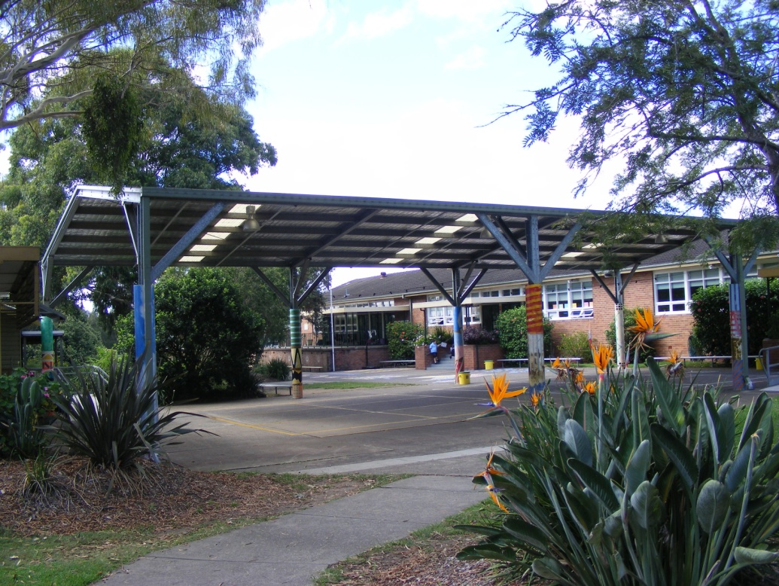

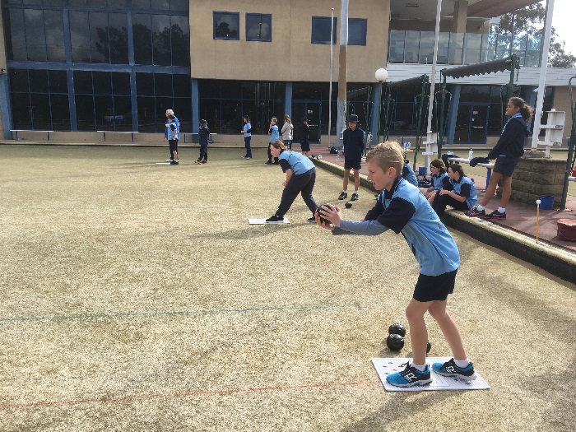

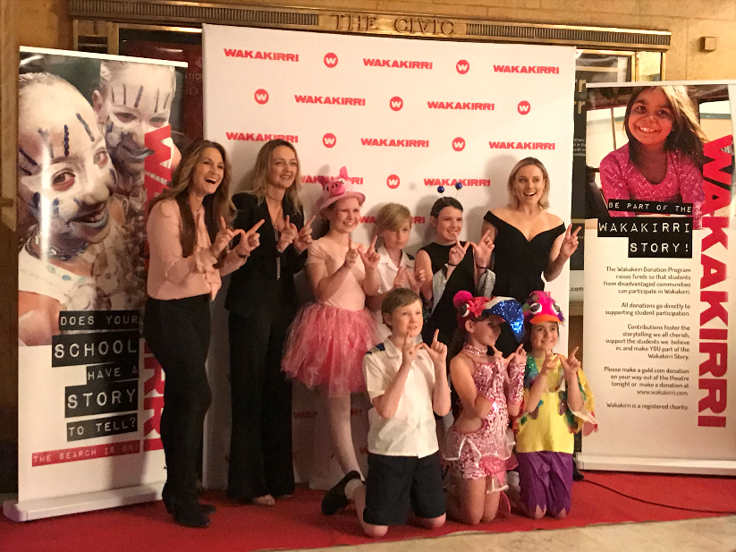

|  |  |  |  |  |  |  |  |  |  |  |  |  |  |  |  |  |  |  |  |  |  |  |  |  |  |  |  |  |  |
| --- | --- | --- | --- | --- | --- | --- | --- | --- | --- | --- | --- | --- | --- | --- | --- | --- | --- | --- | --- | --- | --- | --- | --- | --- | --- | --- | --- | --- | --- |
|  | |  |  |  |  |  | | --- | --- | --- | --- | --- | |  |  | | | | |  | | | | |  | | | | |  |  |  |  | | | | |  |  |  |  |  |  | |  |
| **NSW GOVERNMENT CORE RULES AND SCHOOL DISCIPLINE CODE**  **CORE RULES FOR STUDENTS IN NSW GOVERNMENT SCHOOLS**  **Students in NSW government schools are provided with a high quality education so that they may learn to the best of their ability and become self-disciplined, tolerant, enterprising and contributing members of the school and community.**  **Core rules for student behaviour have been developed to establish consistent expectations in all government schools in support of these aims.**  **These rules are based on our core values of integrity, excellence, respect, responsibility, cooperation, participation, care, fairness and democracy.**  **The critical role of parents and care-givers is recognised as the primary influence on each child’s character and behaviour and as essential partners in supporting the core rules and the successful education of their children.**  **THE CORE RULES**  **All students in NSW government schools are expected to**:  Attend every school day, unless they are legally excused, and be in class on time and prepared to learn.  Maintain a neat appearance, including adhering to the requirements of the school’s uniform or dress code policy.  Behave safely, considerately and responsibly, including when travelling to and from school.  Show respect at all times for teachers, other school staff and helpers, including following class rules, speaking courteously and cooperating with instructions and learning activities.  Treat one another with dignity and respect.  Care for property belonging to themselves, the school and others.  Behaviour that infringes on the safety of others, such as harassment, bullying and illegal or anti-social behaviour of any kind, will not be tolerated.  **TARRO PUBLIC SCHOOL WIDE EXPECTATIONS**  **CODE OF CONDUCT**  The student discipline code and learning environment at Tarro Public School is designed to promote effective learning for all students in a happy and safe environment. This discipline code seeks to nurture and maintain a school environment that values:  RESPECT  We speak politely  We consider others  RESPONSIBILITY  We are in the right place at the right time  We make positive choices  PERSONAL BEST  We challenge ourselves  We create quality work  **STRATEGIES AND PRACTICES TO PROMOTE POSITIVE STUDENT BEHAVIOUR, INCLUDING SPECIFIC STRATEGIES TO MAINTAIN A CLIMATE OF RESPECT**  At Tarro Public School we strive to promote positive student behaviour and a climate of respect through innovative and inclusive programs which serve to support student needs.  Programs include:  **Positive Behaviour for Learning (PBL)**  Positive Behaviour for Learning is a broad range of systemic and individualised strategies for achieving important social and learning outcomes while preventing problem behaviour.  **School-wide Positive Behaviour for Learning Goals**  1. To build systems that make it easier to teach and therefore easier for our students to learn  2. Create environments that encourage (rather than discourage) school-appropriate behaviour  3. Teach all students what is expected  4. Provide a continuum of behaviour and learning support to students who need more support to be successful  Tarro Public School is committed to the PBL system and the school has an active PBL team which plans, reviews, implements and evaluates whole school policies and practices to ensure that our school is happy and safe for all students.  A defining feature of school-wide positive behaviour supports (PBL) is a prevention logic that is organised as a continuum of support, most often in three tiers.   * **Universal Tier (Tier 1)** – School-wide practices and systems for preventing the development and occurrences of problem behaviour for all students across all settings. * **Secondary Tier (Tier 2)** – More specialised and intensive practices and systems for supporting students whose behaviours have been documented as unresponsive to Tier 1 practices and systems. * **Tertiary Tier (Tier 3)** – Highly specialised and individualised practices and systems for supporting students whose behaviours have been documented as unresponsive to Tiers 1 and 2 practices and systems.         **5 Star Rules**  The 5 Star Rules are established in all learning environments within Tarro Public School. These rules underpin Respect, Responsibility and Persona Best and explicit demonstrate expected behaviours of all students in all areas of the school.  C:\Users\mmccann10\AppData\Local\Microsoft\Windows\Temporary Internet Files\Content.IE5\KYCAIN3M\listen.pngC:\Users\mmccann10\AppData\Local\Microsoft\Windows\Temporary Internet Files\Content.IE5\CPTC89DE\wait.pngC:\Users\mmccann10\AppData\Local\Microsoft\Windows\Temporary Internet Files\Content.IE5\PFO9YN5L\instructions.png  C:\Users\mmccann10\AppData\Local\Microsoft\Windows\Temporary Internet Files\Content.IE5\1LKFSC8N\control.pngC:\Users\mmccann10\AppData\Local\Microsoft\Windows\Temporary Internet Files\Content.IE5\PFO9YN5L\quiet.png | | | |  |  |  |  |  |  | |  |
|  | | | |  |  |  |  |  |  | |  |
| **Innovative Curriculum and Quality Teaching Practices**  The Tarro learning community strives to promote an educational climate where curriculum innovation and excellence is encouraged and valued. The school is committed to the NSW “Quality Teaching Model” where the foundations of *Intellectual Quality, Quality Learning Environments and Significance* are embedded in our Whole School Curriculum Plan. This plan outlines stage outcomes for each stage and provides direction in developing “Big Ideas” where students are encouraged to acquire enduring understandings. Classroom learning programs are reflective of this plan and are also needs driven, based on teacher observation and data collection. It is a shared belief of the school that appropriate, needs driven and significant curriculum, reduces negative student behaviour and leads to deeper engagement and learning.  **Student Monitoring / Data Collection**  Tarro Public School is committed to monitoring and encouraging the behavioural and academic growth of all students. The school has several databases to manage and record each student’s behavioural, academic and social progress. Data from these databases is used to determine school priorities and areas of strength.  **Learning Support Team**  The school Learning Support Team (LST) meets regularly to discuss and manage targeted student learning and behaviour. The learning support team consists of the Principal, senior school executive, parents and teachers. The composition of this team changes from time to time, depending on the particular need of each student who may be referred to the LST. Students may be referred to the LST by teachers who are concerned with particular aspects of a student’s growth and development - behavioural, academic, social or emotional. The Learning Support Team discusses strategies to improve particular student outcomes and is responsible for managing support programs throughout the school.  **Transition to School Programs**  The school is committed to promoting positive student behaviours through a strong focus on Kindergarten and High school transition programs. It is believed that these programs are important to establish a climate of trust with the students. The Kindergarten transition program involves Joeys (the weekly school readiness program), parent information sessions, classroom visits by students and a Buddy program where students are paired with older children of the school. Year 6 students are supported through strong links with our partner school Francis Greenway High School and are involved in activities that support their transition to high school. Several visits to Francis Greenway High are organised as part of their transition process as well as various programs throughout the year including Year 9 mentors, Jump Start and Aboriginal transition.  **Learning Assistance Programs**  Learning Assistance programs at Tarro are designed to ensure that children experiencing difficulties in their learning are supported through timely and appropriate intervention. Students who are supported through times of difficulty are less likely to behave in a negative way. Teachers at the school also undertake training and development in ways to cater for children who may be experiencing difficulties. The school also employs a teacher to work with students in classes or withdrawal groups for more individual and intensive assistance.  **School Counsellor**  A School Counselling service is available to students who are experiencing academic, behavioural or social difficulties. Access to this service is through teacher or parental referral. Parental consent must be sought in order for students to visit the school counsellor. Depending on the level and type of need, the school counsellor works with the school community to improve student outcomes and identify possible strategies for the student.  **Attendance Monitoring**  School attendance is recorded through a central marking system at the school office. Student attendance is monitored by teachers and school executive. If a child is absent, a text message will be sent asking for an explanation. It is a legal requirement that all absences are explained in writing or verbally by the parent or caregiver as soon as possible after the absence. Explanations of absences should be given to the class teacher. The Home School Liaison Officer supports the school in its effort to maintain high levels of attendance by the student population.  **Assessment and Reporting**  Positive student behaviour is encouraged through regular assessment of student learning and behaviour. Parent teacher interviews are available at any time on request. Parents wishing to meet with the class teacher should request an interview by phone or in writing. Progress reports are sent home in Term 1 and the whole school conducts parent teacher interviews to establish a partnership with parents and to share some initial observations in classroom behaviour and attitudes to learning. Formal written reports are prepared at the end of Term 2 and Term 4. These reports indicate levels of achievement in the Key Learning Areas and also a summary of behavioural attitudes.  **Student Self-Assessment**  All students at Tarro Public School are encouraged to be active participants in their learning. Students who take responsibility for their learning and regularly evaluate their performance and effort will be more likely to set goals and be more independent, focused and resilient in the classroom. Students will be encouraged to identify strengths as well as areas for development. Much of this self-assessment will take place in the classroom- both formally and informally.  **Student Leadership**  Year 6 students are selected each year to represent their peers in day-to-day routines, ceremonies and general school life. In addition to their normal duties, the student council is also responsible for developing activities in the playground from time to time that reinforces positive interaction and consequences for behaviour in the school.  Children who are displaying an understanding of the school values are allowed to enjoy the benefits of such behaviour. Activities may include: special theme days, lunchtime games and competitions.  All Year 5 students are eligible to nominate to become a school leader for the following year if they have achieved the “Star student” award level. Students who are interested in standing for Captain and Vice-Captain positons are asked to present a speech to the student body. The four students with the highest votes then meet with a member of the school executive to discuss why they would make a good school leader. A staff committee then selects the two School Captains and two Vice Captains, with the remaining students given the opportunity to become either a student leader or House Captain. Student leaders who incur any behaviour infringement forms may lose leadership status temporarily or permanently for the year.  **Anti-Bullying Program**  The school has developed a whole school Anti-bullying policy and program which teaches students about the effects of bullying and how bullying should be handled at our school. At the beginning of each school year teachers will discuss and undertake activities that equip students with an understanding of bullying and how to cope with bullying if it is encountered. Common themes across the school include: the role of power in relationships, types of bullying behaviours, and strategies to cope with bullying, what to do when you see bullying and establishing a support network. (See Anti- Bullying Policy)  **Community Participation**  Tarro Public School seeks to include all community members in supporting students in their learning and behaviour.  Strategies to achieve this goal include:   * Building a learning community in which students, staff and parents work together * Encouraging parents and community members to participate in the education of the students at Tarro Public School * Acknowledging parents as partners * Encouraging students to have a sense of belonging and ownership to the school * Assisting families to gain access to support services in the community * Fostering close links with the wider community * Encouraging links between parent and student representative groups * Inviting parents to share their skills and experiences in the school community * Supporting students and their parents in making decisions about learning programs * Recognising students’ families, cultures, languages and life experiences   **Friday Incentive Time (F.I.T.)**  Friday Incentive Time (FIT) is a positive reward for students who has received no referral forms (Red or orange) for the week. It’s focus is an incentive for students to strive to achieve positive behavior throughout the week. FIT is run on a Friday afternoon for 30minutes. Students are able to choose organised and structured activities run by the teachers. Students who have received a referral form for the week will participate in NON-F.I.T. which involves discussing the incident that resulted in a referral form/s and participating in structured lessons/activities involving social skills.  **Relief Teachers**  At Tarro Public school we strive for high expectations of consistency and communication between all members of staff. Relief teachers/visiting teachers are given an induction regarding the school’s Workplace, Health and Safety, as well as a folder regarding class information, programming, timetables and behaviour systems upon their arrival to the school.  **STRATEGIES AND PRACTICES TO RECOGNISE AND REINFORCE STUDENT ACHIEVEMENT**  **WHOLE SCHOOL AWARD SYSTEM**  **VALUE MERIT AWARDS**  Positive student behaviour will be recognised through a reward system based on the PBL school values. Students throughout the year will receive awards from the classroom teacher for demonstrating a commitment to the three values of:      **Merit award procedures:**  🗸 Merit Awards are handed out each week in the school’s whole school assembly.  🗸 Each class teacher will nominate three students each week to receive a merit award- one of each value merit award  🗸 Students must collect one of each value to receive the Star Student Award  🗸 Emphasis is on showing all three values consistently  🗸 Students can receive additional awards once the Star Student Award has been achieved  🗸 Central tracking system kept in the school  🗸 Star Student awards are not given out until Term 4 each year- at a Star Student Awards ceremony. Students receive an award as well as a yearly badge displaying their Star Student status  **Other requirements/conditions to be met:**  🗸 Students who have **more than one** suspension and/or **more than 4** behaviour referral forms throughout the year are ineligible for the star award for that year.  🗸 Students will lose “Star student status” if the student fails to maintain the expected behaviour of a star student (See condition above)   * Students in Year 5 must have their Star Student status to be eligible for leadership in the following year   **Other Awards**  **Brights**  Bright awards are given out by all school staff to encourage students and reward good behaviour on a regular basis. Students collect 10 brights to earn a ‘Bright Star’ which is worth $1 at the canteen.    Brights can be given out for a variety of reasons:  **Classroom behaviours examples:**  Completing work  Persisting with tasks  Helping others  Listening attentively  Speaking politely  Cleaning the classroom  Organisation  **Playground Behaviours examples**:  Tidying the playground  Volunteering to help others  Playing cooperatively  Staying in the right area  Using equipment properly  **Representative Awards**  Students are awarded with “Representative Awards when they represent the school in Academic, Sporting or cultural activities. (These do not count towards the star student award)    **Attendance Awards**  Students who have over 95% attendance in the Term are awarded an “Attendance Award”    **Other Strategies to Promote Positive Behaviour**   * Ongoing feedback to students for appropriate behaviour (particularly the three school values) * Staff modelling of consistent, caring and controlled behaviour * Commendations and recognition at assemblies, in the weekly newsletters and at special occasions * Regular contact with parents and caregivers * Verbal praise and recognition * Participation in PSSA competitions, public speaking, Spelling Bee and Performing Arts festivals/performances * Recognition of students with special needs, remediation and programs for gifted and talented   students   * Student Self Evaluation Checklists * Home reading program and awards * If applicable- FIT (Friday Incentive Time)   **STRATEGIES AND PRACTICES TO MANAGE INAPPROPRIATE STUDENT BEHAVIOUR**  **Classroom Management of Inappropriate Student Behaviour**  The classroom teacher (including the RFF teacher) plays a pivotal role in maintaining a positive classroom environment and promoting productive relationships with each student. From time to time the teacher will need to manage student behaviour which is not in keeping with the school’s and/or teachers expectations. It is important that the teacher understand their role in restoring the student’s behaviour to a more acceptable standard. All teachers are asked to use the school’s agreed ‘classroom procedures’ when managing student’s behaviour (See following pages).  It is an expectation that teachers will enforce fair and firm discipline procedures to maintain the class’ learning focus. Where consequences (time out, plan for improvement etc.) are applied, the individual teacher is responsible for following through and managing the restorative process. Giving control over to another teacher to discuss the inappropriate behaviour does little to change the relationship between teacher and student. In extreme or serious circumstances, the student may be referred immediately to the stage leader or Principal.  **Playground Management of Inappropriate Student Behaviour**  All staff members must be vigilant when supervising playground play to ensure a safe and happy playground. All staff members should carry a playground folder and wear a fluorescent vest. From time to time students will need to be reminded of rules and expectations. Consequences for inappropriate behaviours will range depending on severity and context. Where incidents are minor, students should be reminded of rules and where appropriate have consequences to reinforce better choices. Where the behaviour is more significant or serious, teachers will need to apply the schools policies and procedures (see following pages). Where possible it is the supervising teacher’s responsibility to follow through with an appropriate investigation and referral where necessary. This may involve interviewing students after the play period has ended. Serious behaviour infringements must be referred to a stage executive and/or principal.  **Staff expectations- Classroom and Playground**   |  |  |  |  | | --- | --- | --- | --- | | **Area** | **Teacher** | **Stage Executive** | **Principal** | | **Classroom** | 🞄 Establish class routines and expectations  🞄 Follow agreed school classroom management procedures  🞄Investigate behaviour incidents as needed.  🞄 Follow through with enforcement of consequences for misbehavior  🞄Contact parents to enlist support and advice  🞄 Conference with student- make a plan, contract etc. with agreed consequences  🞄 Record inappropriate significant classroom behaviour on referral form (Orange or Red Form)  🞄 Maintain acceptable documentation of behaviour- plans, referrals  🞄Communicate with stage executive  🞄Refer to stage AP for serious and/or ongoing behaviour causing concern. | 🞄Ensure school policies and procedures are followed  🞄Support and advise classroom teacher where appropriate  🞄 Collect “significant” inappropriate behaviour forms(orange forms) and record on sentral database (office to support) in Week 4 and Week 9  🞄 Investigate serious behaviour incidents for principal | 🞄Ensure school policies and procedures are followed  🞄Support Stage APs  🞄Convene LST meeting to address student need  🞄 Apply DET suspension policies where necessary | | **Playground** | 🞄 Know school playground rules and routines  🞄 Roam constantly in duty area  🞄 Reinforce playground rules  🞄 Investigate playground incidents  🞄 Record inappropriate significant playground behaviour on referral form (Orange or Red Form)  🞄 Ensure orange forms are directed to stage AP | 🞄 Support and communicate playground policies and procedures  🞄 Support teachers in consistency and procedures  🞄 Collect and record behaviour referrals- orange and red- on sentral database  🞄 Investigate serious incidents for principal | 🞄Ensure school policies and procedures are followed  🞄Support Stage APs  🞄Convene LST meeting to address student need  🞄 Apply DET suspension policies where necessary |   **Classroom and Playground Procedures**  All students at Tarro Public School are encouraged to show behaviour in classrooms that are in keeping with our school expectations of  **RESPECT RESPONSIBILITY**  **PERSONAL BEST**  **Possible Consequences for breaches of School Wide expectations**   |  |  |  |  |  |  | | --- | --- | --- | --- | --- | --- | | **Behaviour level and consequences** | **PLAYGROUND** | | **CLASSROOM** | | **Recording**  **Method** | | **Typical Behaviours-** | **Possible Consequences** | **Typical Behaviours-** | **Possible Consequences** | | **1. Minor infringements of school expectations - counselling by the teacher, low level consequences and restitution** | **Examples:**  - Running on  Concrete  - Minor  teasing/  name calling  -out of bounds  - inappropriate use  of equipment  - no hat  - Inappropriate language without intent  - Refusal to follow instruction  - Rough play on playground  - Out of bounds | - Counselling /Discussion  - Reminder of 5 Star Rules  - Time out in visible area  - Walk with teacher | **Examples:**  - Calling out,  lack of effort, interrupting others,  - out of seat without permission  - Not listening or following instructions  - Throwing paper/littering  - Name calling | - Counselling /Discussion  -Reminder of 5 Star Rules  - Moving down flowchart  - Time out in visible area  - Lunch/Recess time out  - Parent contact | **None** | | **2. Significant infringements of school expectations- counselling by the teacher, recording of behaviour and restitution** | **Examples**:  - Low level bullying  - Not following instructions and reasonable requests  - Dangerous play  - Continued out of bounds  - Physical violence/threats towards teacher or students | - Walk with teacher  - School beautification  - Apology to affected students  - Time out in visible area | **Examples:**  - Persistent interruptions to class routines  - Continual interruptions to the learning of others  - Refusing to complete work  - inappropriate language towards staff/students  - Continued lateness to class  - Not completing classroom level discipline procedures e.g. time out | - Names moved down Flowchart  - Completion of work in lunch/recess  - Students of concern identified at LST meeting, executive and communications meeting  - Loss of privileges  - 5 orange forms (loss of Star Student award)  - Referral for Tier 2 intervention (consistent behaviour) | **Orange Behaviour Form-** Collected by Executive and entered onto database | | **3. Serious infringments of school expectations- investigation by the teacher and/or school executive, recording of behaviour, enforcement of conesuquences and resitituion** | **Examples**:  - Physical Violence- Fighting, punching, kicking, hitting  - Use of Weapons-  - Possession of illegal substances  - Ongoing bullying/ intimidation  - Serious non compliance  - Serious lack of regard for respect, responsibility or safety | - Parent  Interview  - Time out of playground  - In school withdrawl  - Suspension  - Expulsion | **Examples**:  - Physical Violence- Fighting, punching, kicking, hitting  - Use of Weapons-  - Possession of illegal substances  - Ongoing bullying/ intimidation  - Serious non compliance  - Serious lack of regard for respect, responsibility or safety | - Parent  Interview  - Time out of playground  - In school withdrawl  - Suspension  - Expulsion  - Students of concern identified at LST meeting, executive and communications meeting | **Formal Behaviour Form**  **(Red Form)**  - Teacher/  Executive conference  - Sentral Database  - Parent interview/ phone call/ interview as appropriate |   Inappropriate behaviours may result in any of the following consequences depending on severity, frequency and context.   * Counselling - teacher and students discuss better behaviours and consequences. * Time-Out - student is removed from normal class setting - either in a quiet area of the classroom or in another class. * Recording in orange forms - student behaviour is recorded for possible further counselling and consequences - Incident is recorded on Sentral * Red Form – serious incident or culmination of repeated misbehavior * Referral to LST- behaviours of concern can be referred to the Learning Support Team * Parents contacted by letter/phone * Suspension Caution - Parents are informed by phone or letter * Suspension     **Consistent Classroom Management**  All classrooms at Tarro Public School will operate a level system. This system aims to promote a positive and safe environment for all students.  ***Level system explanation:***   |  |  |  | | --- | --- | --- | | **Level** | **Comments**  **Questions/ Directions** | **Consequences** | | **Brightstar!**  **(Bright award)** | **STUDENT RECEIVES A BRIGHT AWARD**  **Possible prompts:**  🞈 Great Work!  🞈 Well done!  🞈 You are showing Respect/Responsibility/ Personal Best | * Bright Award * 10 Brights = $1 canteen voucher | | **Keep it Up!** | **Possible prompts:**  🞈 Great work - you are staying on task! | * Rewards- praise, stickers, awards * Choices in learning * Feeling good * Having friends * Enjoying school | | **STAR** | **Behaviour NOT showing Respect/Responsibility/Personal Best**  **Visual warning**  **Possible prompts:**  🞈Great work – you are staying on task  🞈Well done for following instructions | * Rewards- praise, stickers, awards * Choices in learning * Feeling good * Having friends   Enjoying school | | **Warning – Can you make a better choice?** | **Behaviour NOT showing Respect/Responsibility/Personal Best**  **Visual warning**  **Possible prompts:**  🞈What is your job?  🞈Do you need to change your behaviour/thinking?  🞈Are you interrupting the learning of others?  🞈What are you choosing to do?🞈 What are you seeking?  🞈 Are you choosing time out? | * Monitoring * Redirecting/ discussion * In class timeout * Classroom consequence * Possible recess/lunchtime discussion * Contact parent/carer | | **Time**  **Out** | **Behaviour NOT showing Respect/Responsibility/Personal Best**  Student is directed to have time out in buddy class. Teacher writes out “time out slip”- Student returns to room after time out.  **Possible prompts:**  🞈 You are choosing inappropriate behaviour.  🞈 You do not have the right to do that.  🞈 Move to time out (buddy class) –  🞈 Thank you for taking time out - let’s get back to work. | * Behaviour Recorded on orange form (Compulsory) * Time out in buddy class * Possible Lunchtime discussion/plan with teacher * Parents informed * Loss of rewards * Possible- Tier 2 Intervention | | **EXIT** | **Behaviour NOT showing Respect/Responsibility/Personal Best**  Students who continue to not show respect, responsibility or excellence are removed from the class for the remainder of the day.  **Possible prompts:**  🞈 Please wait quietly whilst another teacher is called to remove you from the classroom | * Removal from class by executive (Compulsory) * Recording of behaviour -Red Form * Parents informed * Possible Suspension/loss of rewards and privileges * Possible recess/lunchtime withdrawal |   **✰TEACHERS MAY MOVE STRAIGHT TO SERIOUS CONSEQUENCES RECORDING (RED FORM) IF THERE IS A SERIOUS INCIDENT OR BEHAVIOUR.✰ALL STUDENTS TO START SESSION ON THE STAR LEVEL.**  **Restorative Practices (Justice)**  At Tarro PS and as a member of the “Gateway Learning Community” (GLC) of schools, we believe in dialogue and engagement through restorative conversations.  The aim of Restorative Practice is to strengthen relationships and manage conflict and tensions by repairing harm as a way of building both individuals and community.  Good relationships are the basis for good learning.  Anything that affects relationships such as inappropriate classroom and playground behaviour impacts upon the quality of learning.  At Tarro PS we deal with anything that goes wrong in a restorative way.      **Excursions or other outside school activities**  **(Including sporting events)**  All events occurring within the auspices of the school, including excursions, sporting and cultural events, are governed by the school’s discipline policy and code of conduct. Unacceptable behaviour will be recorded in accordance with all other behaviour records. Consequences for unacceptable behaviour during outside of school activities will depend upon the circumstances involved.  **Consequences**  While this policy is founded upon a counselling environment for the management of behaviour emphasising skills and understandings in problem solving, decision making, communication and personal responsibility, consequences remain an important feature of the discipline strategy at Tenambit Public School.  Over and above the systems outlined in the policy, the school may choose to impose consequences which either seek restitution (such as repairing damage), withhold privileges, restrict playing areas or completely remove students from the playground or classroom for a specified period.  Where a student has persistently breached the code of conduct of behaviour or misbehaved in such a way that his or her conduct may be deemed to present a threat to the safety and welfare of others, the school may choose to exercise its discretionary powers by excluding the student from excursions, class outings, sporting events, inter-school competitions, visiting performances, class parties, discos and Year 6 farewells.  In such cases, the student will be warned that such an action is being considered and the student’s parents will be advised in writing that such a warning has been given and the reasons supporting such considerations.  **Communicating with Parents**  Parents will be formally notified in cases where:   * a student has repeatedly breached classroom or playground behaviour standards and has been   directed to write plans for improvement   * exclusion from outside of school activities ( all school based activities such as excursions, camps,   inter-school sport or other competitions, and visiting performances) is being considered   * serious breaches of school rules/code of conduct have occurred. Parents will be informed of the   actions being taken by the school to address these issues and consequences of any further  breaches. In the case of violent behaviour, threats of violence, or persistent disobedience, parents  will be notified immediately and issued with a copy of **“ Procedures for the Suspension and**  **Expulsion of School Students**” (DET 2011) and advised of intended action by the school   * suspension or expulsion is being considered by the school * suspension or expulsion is being enacted, including details as outlined in the suspension section of this policy   **Anti-Bullying Plan**  Bullying in any form is unacceptable. It devalues, isolates, frightens, affects an individual’s ability to achieve and has long-term effects on the bully, those being bullied and the by-standers. Bullying behaviour is intentional and often repeated. It is an abuse of power that causes distress, hurt or undue pressure.  Bullying behaviour can be:  **Verbal-** name calling, teasing, abuse, putdowns, sarcasm  **Physical-** hitting, punching, kicking, scratching, tripping  **Social-** ignoring, excluding, ostracising, alienating, gestures  **Psychological-** spreading rumours, dirty looks, hiding possessions, malicious SMS and email, inappropriate phone calls  The school will respond to concerns and provide appropriate support.  **Reporting**: All members of the school community (students, parents/carers and teachers) have the responsibility to report all forms of bullying.  The Principal and Assistant Principal will manage incidents of bullying but reports can be made to any teacher on staff.  **Intervention and Support:** The school implements a whole school anti-bullying program in the first term of each year. Further, anti- bullying awareness is maintained throughout the year. In general incidents of bullying will be dealt with in accordance with classroom and playground behaviour management procedures. Students may also be offered help which may include interviews, counselling, peer mediation or other strategies. In cases of serious or persistent bullying the School Discipline Policy will be followed.  **Student Health and Medication**  Students requiring ongoing medical attention and/or medication will have an individual health plan prepared by their parents/carer, their doctor and the school.  Asthma puffers are the only medication that students are allowed to have in their possession. Some students may be allowed to carry other medications as part of a health care plan. Such health care plans must be developed in consultation with the Principal and parents/guardian.  Where a short term medical condition requires treatment at school, the parents must complete a “**REQUEST FOR SUPPORT AT SCHOOL OF A STUDENT’S HEALTH CONDITION”** form- available from the office.  From time to time students may be sent from class to the school office due to illness. The Principal and/or office staff will assess student needs and notify parents should collection be necessary. Parents are asked to keep emergency contact phone numbers up to date to avoid collection problems and distress to the child.  More specific information on student health can be found in the school’s health policy and the DET website: https//det.nsw.edu.au  **School Attendance**  The law in NSW (Education Act 1990) states that all children between the ages of six and fifteen years are required to attend school regularly. It is the responsibility of parents or caregivers to make sure that their children attend school every day. Children may be absent from school due to illness, injury, a special religious ceremony, infectious diseases (e.g. chicken pox, mumps or measles) or if there is a serious family situation which requires student involvement.  Please do not keep your child away from school for: birthdays, pension day, minding other children, hair cuts and/or interpreting for other family members.  Families should try to arrange holidays during school vacation periods. If you can only arrange your family holiday during school time, you should inform the school principal in advance and request permission for your child to be absent.  Parents must notify the school of the reasons for a child’s absence- either by phoning the school or completing a written note on the day of the child’s return to school.  Attendance is monitored closely through a central roll system and students with unsatisfactory attendance may be referred to the district Home School Liaison officer.  **Homework**  Homework is a valuable part of schooling. It allows for practising, extending and consolidation of work done in class. Homework provides training for students in planning and organising time and develops a range of skills in identifying and using information sources. Additionally it establishes habits of study, concentration and self-discipline. Class teachers will assign homework regularly to support and consolidate classroom learning. Parents play an important role in supporting their child in the development of important learning and concepts.  **Uniform**  The school’s Uniform Policy is made available to all new enrolments to assist parents in dressing children in correct uniform. The wearing of uniforms is encouraged and monitored. Parents of students who are not wearing correct uniforms on a regular basis are contacted. The uniform policy is determined through discussion with the parent groups (ie. P&C Association) and the community.  **Home Reading Program**  Reading is the single most important skill the child will learn at school and while many children have developed reading skills, further development depends on using these skills regularly.  Parents are asked complete home reading record of the student’s reading each night. Parents are asked to sign for each night the child reads (holiday periods and weekends can be included). The time spent reading each night will depend on the age of the student, other homework tasks and family schedules.  **Awards will be provided:**  25 nights - 25 reading sessions - class certificate.  **50 nights** - 50 reading sessions – certificate presented at assembly  75 nights - 75 reading sessions - class certificate.  **100 nights -** 100 reading sessions - A large certificate presented at assembly  125 nights - 125 reading sessions - class certificate.  **150 nights** - 150 reading sessions – certificate presented at assembly  175 nights - 175 reading sessions - class certificate.  **200 nights** - 200 reading sessions - A large certificate is presented at assembly and a book is presented at Presentation Day.  **Suspension Procedures**  **(These procedures should be read in conjunction with the current DET policy)**  **See: "DET Suspensions and Expulsions Policy 20011"** **https://www.det.nsw.edu.au/policies**  **INTRODUCTION**  • All students and staff have the right to be treated fairly and with dignity in an environment free from disruption, intimidation, harassment and discrimination.  • There will be cases of unacceptable behaviour where it will be in the best interests of the school community and/or the student involved, for the student to be removed from the school for a period of time or completely. Suspension and expulsion are the options available to the principal in these situations.  • In such cases of unacceptable behaviour, parents should not be asked to keep students at home without the formal imposition of a suspension unless this is for the remainder of a school day as part of an approved behaviour management program.  • In implementing these procedures, the principal must ensure that no student is discriminated against on any of the following grounds:  * race, including colour, nationality, descent, and ethnic, ethno-religious or national origin  * sex  * marital status  * disability, including HIV/AIDS  * homosexuality  * transgender, or  * age.  • The principal must also ensure that the implementation of these procedures takes into account factors such as the age, individual needs, any disability and developmental level of students.  • Suspension is not intended as a punishment. It is only one strategy for managing inappropriate behaviour within a school’s student welfare and discipline policies. It is most effective when it highlights the parents’ responsibility for taking an active role, in partnership with the school, to modify the inappropriate behaviour of their child. The school and the government school system will work with parents with a view to assisting a suspended student to rejoin the school community as quickly as possible.  • Suspension also allows time for school personnel to plan appropriate support for the student to assist with successful re-entry. This may include access to appropriate support staff such as an Aboriginal community liaison officer (ACLO) or support teacher behaviour (STB). In some cases suspension from school allows the school and government school system time to put measures in place to ensure the safety of students and staff. For the majority of students, suspension allows time for the student to reflect on their behaviour, to acknowledge and accept responsibility for the behaviours which led to the suspension, and to accept responsibility for changing their behaviour to meet the school’s expectations in the future.  • The principles of procedural fairness are fundamental to the implementation of these procedures. Procedural fairness is generally recognised as having two essential elements. These are:  * the right to be heard, and  * the right of a person to a fair and impartial decision.  • These procedures apply to the behaviour of students at school, on the way to and from school and while away from the school site on school endorsed activities. They can also apply outside of school hours and off school premises where there is a clear and close connection between the school and the conduct of students. This includes the use by a student of social networking sites, mobile phones and/or other technology to threaten, bully or harass another student or a departmental staff member for school related issues.  **SUSPENSION**  ***General Principles***  • In determining whether a student’s misbehaviour is serious enough to warrant suspension, the principal will consider the safety, care and welfare of the student, staff and other students.  • Before a suspension is imposed, with the exception of the cases outlined in dot point 4 below or other serious instances of misbehaviour that impact on the safety or welfare of students or staff, the principal will ensure that appropriate school student welfare strategies and discipline options have been applied and documented.  • In some circumstances the principal may determine that a student should be suspended immediately. This will usually be due, but not limited, to reasons such as the safety of students or staff.  • When consideration has been given to factors such as age, disability and developmental level of students (amongst others), principals must suspend immediately and consistently with these procedures, any student who:  **\* is physically violent: Any student who is physically violent, resulting in injury, or whose violent behaviour seriously interferes with the safety and well being of others is to be suspended immediately.**  **\* is in possession of a firearm, prohibited weapon, (as defined by Schedule One of the Weapons Prohibition Act), or knife (without reasonable cause).**  **\* uses, supplies, or is in possession of, a suspected illegal substance (not including alcohol or tobacco) or supplies a restricted substance.**  **\* engages in serious criminal behaviour related to the school**.  • Schools should ensure that in meetings with school personnel, in cases where communication difficulties arise due to a lack of understanding of English, parents have access to the use of an on-site or telephone interpreter and receive translated letters notifying of suspension or expulsion. Consideration may also need to be given to cultural issues and the intellectual capacity of the parent to understand what is occurring and what is being said. For details on arranging an on-site or telephone interpreter, refer to: http://www.schools.nsw.edu.au/adminsupport/intertranslate.php  • In all cases of suspension:  * a formal disciplinary interview must be held with the student prior to making the decision to impose a short suspension. Principals must ensure that the student is given explicit information about the nature of the allegation(s) and is given the opportunity to consider and respond to the allegation(s).  The key features of the interview must be taken down in writing  * a suspension resolution meeting must be convened by the principal at the earliest opportunity .The principal, in conjunction with the parents, should utilise the school, regional and other available resources in seeking a means of assisting the student to modify his or her behaviour.  • Should parents require a support person in order to participate fully in the suspension resolution or expulsion meeting, a person acceptable to both the parents and the principal may be involved, e.g. a member of the local Aboriginal Education Consultative Group (AECG) or disability worker. The responsibility for organising a support person rests with the student or parents.  ***b. Short Suspension***  • In cases where a range of appropriate student welfare and discipline strategies have been implemented and been unsuccessful in resolving the inappropriate behaviour or the principal determines the behaviour of the student is of a type that warrants immediate suspension, the principal may choose to impose a short suspension of up to and including four school days. Short suspensions may be imposed for the following reasons and will be reported in the following categories:  **1. Continued Disobedience. This includes, but is not limited to, breaches of the school discipline code such as: refusal to obey staff instructions; defiance;**  **disrupting other students; use of alcohol or repeated use of tobacco.**  **2. Aggressive Behaviour. This includes, but is not limited to hostile behaviour directed towards** **students, members of staff or other persons, including: damaging the property of the school or students; bullying (including cyberbullying); verbal abuse, and abuse transmitted electronically such as by email, SMS text messages or by other electronic means.**  ***c. Long Suspension***  • If short suspensions have not resolved the issue of inappropriate behaviour, or the misbehaviour is so serious as to warrant a long suspension, the principal may impose a long suspension of up to and including 20 school days. In determining if a student’s behaviour is serious enough to warrant a long suspension the principal must consider:  * the safety of students and staff  * the merit and circumstances of the particular case  * factors such as the age, individual needs, any disability and developmental level of students.  • Subject to factors outlined in the dot point above, principals will impose a long suspension for:  **\* Physical violence:** Which results in injury, or which seriously interferes with the safety or well being of other students and staff (including sexual or indecent assault).  **\* Use or possession of a prohibited weapon, firearm or knife.**  When the student:  • uses or possesses a weapon which is listed in Schedule One of the Weapons Prohibition Act. Prohibited weapons include laser pointers, or similar articles with a power output of more than one milliwatt. Prohibited Weapons do not include harmless children’s toys such as plastic imitation guns that are clearly intended to be toys;  • uses a knife or possesses a knife (without reasonable excuse as defined by the Summary Offences Act*);  • uses or possesses a firearm of any type (including live ammunition, and replica firearms).  *Note – “reasonable excuse” includes Kirpans carried by Sikhs for religious purposes.  **\* Possession, supply or use of a suspected illegal substance.** This does not include alcohol or tobacco, but does include supplying other students with illegal drugs or restricted substances such as prescription drugs.  **\* Serious criminal behaviour related to the school.** This includes malicious damage to property (school or community), or against the property of a fellow student or staff member on, or outside of the school premises.  • Subject to factors outlined in the first dot point in this section (section c), principals may also impose a long suspension for:  **\* Use of an implement as a weapon.** When a student uses an implement as a weapon to assault or injure another person (including use of an offensive implement, which is any implement made, or adapted to cause injury to another person).  **\* Persistent or serious misbehaviour.** This includes, but is not limited to:  • repeated refusal to follow the school discipline code;  • threatening to use a weapon in a way that might seriously interfere with the safety and wellbeing of another person;  • making credible threats against students or staff;  • behaviour that deliberately and persistently interferes with the rights of other students to learn or teachers to teach including bullying, harassment and victimisation.  • In the formal disciplinary interview, the student must be able to have an appropriate observer of their choosing present at the interview.  • The principal will not impose any more than two long suspensions on an individual student in any twelve month period without the approval of the school education director.  • If, after two long suspensions, the matter has not been resolved other strategies must be considered including alternative educational placements, expulsion from the school or expulsion from the school with a recommendation to the Minister that the student not be re-admitted to all or any government schools.  ***DECIDING ON, NOTIFYING AND RESOLVING A SUSPENSION***  • The decision to suspend must be taken by the principal, or in the principal’s absence, the person performing the principal’s role (relieving principal).  • A student will not be sent out of the school before the end of the school day without notification being made to their parents and, if necessary, agreement reached about arrangements for the collection of the child from school.  • Notification of suspension must be made to the parents in writing within 24 hours following immediate verbal notification.  • The principal must convene a suspension resolution meeting of personnel involved in the welfare and guidance of the student, including the parents, to discuss the basis on which the suspension will be resolved.  • If parents are unable or unwilling to attend a suspension resolution meeting, the principal should consider the individual merits of the case and attempt to ensure that the student is back at school on or before the concluding date of the suspension period.  • Where a student is returning from suspension following an incident that involved violence or weapons, the principal must undertake a risk assessment in order to assess whether the return of the student will pose a risk to staff, students or other persons. This should be completed before the final day for resolution of the suspension.   * When a student is returning from suspension, they may be placed on Tier 2 Intervention after an ERASE form is completed by the principal and/or executive. This will be up the discretion of the Principal and dependent on the student’s behaviour. The student may also use a behaviour monitioring card (Check up card) for a negotiated timeframe.   • The student should not be re-admitted to the school until the issues identified in the risk assessment have been addressed. If the issues cannot be addressed before the final day of the suspension, the principal must refer the matter to the school education director who will consider a range of measures to resolve the issues. While this is occurring it may be necessary to impose a second long suspension.  ***EXPULSION***  a. General Principles  • In serious circumstances of misbehaviour the principal may expel a student of any age from their school. The principal may also expel a student who is over 17 years of age for unsatisfactory participation in learning.  • In all cases where expulsion is being considered the principal must:  * notify the student and the parents, in writing, that expulsion from the school is being considered, giving reasons for the possible action  * organise an interpreter or cultural assistance and/or translated documents, or other assistance for disability issues as appropriate, in order to allow parents to participate fully in the process  * obtain and consider a report from the learning support team or school counsellor, as appropriate, that includes recommendations for further action  * provide the parents with a copy of all documentation on which the consideration of expulsion is based  * allow seven school days for students and parents to respond  * consider any response from the student and parents before proceeding further  * discuss with the student and the parents the implications of expulsion and provide information relating to the right to, and process for, an appeal.  b. Expulsion from a Particular School for Misbehaviour  • When considering expelling a student for misbehaviour, the principal must:  * ensure, except as a result of a most serious incident, that all appropriate student welfare and discipline strategies have been implemented and documented  * convene a formal disciplinary interview with the student. Principals must ensure that the student is given explicit information about the nature of the allegation(s) and is given the opportunity to consider and respond to the allegation(s). The student must also be able to have an appropriate observer of their choosing present at the interview. For very young students or students with certain disabilities it may be advisable to have a parent present at the meeting  * place the student on a long suspension pending the outcome of the decision making.  • Having reached a decision to expel a student from the school, the principal will:  * inform the student and the parents in writing. This formal advice should also restate the right to appeal the decision  * arrange, within 10 school days, and with support from regional staff, an alternative educational placement appropriate to the needs of the student.  • If a suitable alternative cannot be arranged the principal must refer the issue to the school education director for resolution.  • In the resolution process the school education director may consider a range of options including:  * directing, with approval from the regional director, the re-admittance of the student to the school, subject to strict disciplinary arrangements as necessary to ensure the safety and welfare of the student, other students and staff  * placement in an alternative education setting  * enrolment in TAFE  * participation in other education or training approved by the Minister  * enrolment in distance education, or  * recommending to the regional director that another school be directed to enrol the student (subject to any issues that may have been identified by a risk assessment, having been addressed).  • In the majority of cases, expulsion from a particular school for misbehaviour will be finalised within the 20 school day period of a long suspension. In the unlikely event that this cannot be achieved, a second long suspension may be imposed provided approval is given by the school education director.  • If the student’s behaviour has been so extreme that a suitable alternative placement cannot be found, the school education director in consultation with the principal, may forward a submission to the Director-General, through the regional director and the Deputy Director General (Schools), recommending to the Minister that the student who has been expelled for misbehaviour not be re-admitted to all or any government schools.  c. Expulsion from a Particular School of a Student over 17 Years of Age for Unsatisfactory Participation in Learning  • This will generally be where a student has failed to apply themselves with diligence and sustained effort to set tasks and experiences and the lack of application is impacting on the good order of the school and learning of other students.  • Prior to giving consideration to expulsion the student must receive at least one formal written warning that such action is being contemplated. A program of improvement should be developed in conjunction with the student to assist them to improve their participation in learning. The student must also be provided with a reasonable period in which to demonstrate improvement.  • When considering expulsion in these circumstances, the principal will notify the student and the parents, in writing, that expulsion from the school is being considered, giving reasons for the possible action. There is no necessity to place the student on long suspension pending the decision making process in these circumstances.  • Having reached the decision to expel the student from the school the principal will inform the student and the parents in writing. This formal advice should also restate the right to appeal the decision.  • The arrangement of an alternative placement is the responsibility of the student and the student’s parents. Advice for students and parents in these circumstances is available from the appropriate regional office.  ***APPEALS***  • Students and parents may appeal if they consider that correct procedures have not been followed, and/or that an unfair decision has been reached.  • Some students or parents will require assistance in lodging an appeal. Students or parents requiring assistance should be referred in the first instance to the regional office. Regional office personnel should identify appropriate support people for the student or parents if this type of assistance is requested. Appeals can be made to:  1. The school education director about the imposition of a suspension or a decision to expel a student from a particular school.  2. The regional director where a school education director has been so involved in a decision to suspend or expel a student from a particular school as to prevent him or her, on the grounds of procedural fairness, from deciding an appeal.  3. The regional director about the decision of a school education director to decline an appeal relating to a suspension or an expulsion from a particular school.  • The school education director or regional director will:  * deal with the appeal within 20 school days of its lodgement  * ensure that communication lines are maintained with the person(s) making the appeal and that they are kept aware of the progress of the appeal  * review all relevant material  * ensure that appropriate material has been made available to the student and his or her parents  * discuss relevant issues with the person(s) making the appeal and any other parties, as appropriate  * advise all the parties of the decision and the specific reasons for reaching the decision.  • Where an appeal or a component of an appeal is upheld, the person determining the appeal will decide what further action is to be taken. Further action will be determined by the findings of the appeal.  • The fact that an appeal has been lodged does not put on hold the principal’s decision to suspend or suspend prior to expulsion from a particular school.  NOTE: In these procedures, the term "parent" or "parents" includes any person or persons having the custody or care or a child | | | |  |  |  |  |  |  | |  |
|  | | | |  |  |  |  |  |  | |  |
|  | | | |  |  |  |  |  |  | |  |
|  | | | |  |  |  |  |  |  | |  |
|  |  |  |  |  |  |  |  |  |  | |  |
|  |  |  |  |  |  |  |  |  |  | |  |
|  |  |  |  |  |  |  |  |  |  | |  |
|  | | | | | | | | |
|  |  | | | | | | | |
|  |  | | | | | | | |
|  | | | | | | | | |
|  |  | | | | | | | |
|  |  | | | | | | | |
|  | | | | | | | | |
|  |  | | | | | | | |
|  |  | | | | | | | |
|  | | | | | | | | |
|  |  | | | | | | | |
|  |  | | | | | | | |
|  | | | | | | | | |
|  |  | | | | | | | |
|  |  | | | | | | | |
|  | | | | | | | | |
|  |  | | | | | | | |
|  |  | | | | | | | |
|  | | | | | | | | | | |
|  | | | | | | | | | | |
|  | | | | | | | | |  | |

